**Master DB Corruption**  
*************************

**Pre-requisite**

--You must have latest backup of master DB

--Do plan outage (down time) because for this SQL services need to stop/restart and we have to put instance in single user mode, that means no application cannot connect to SQL server, In single user mode only one sys admin user account can login.

--Check if we have latest backup of master DB

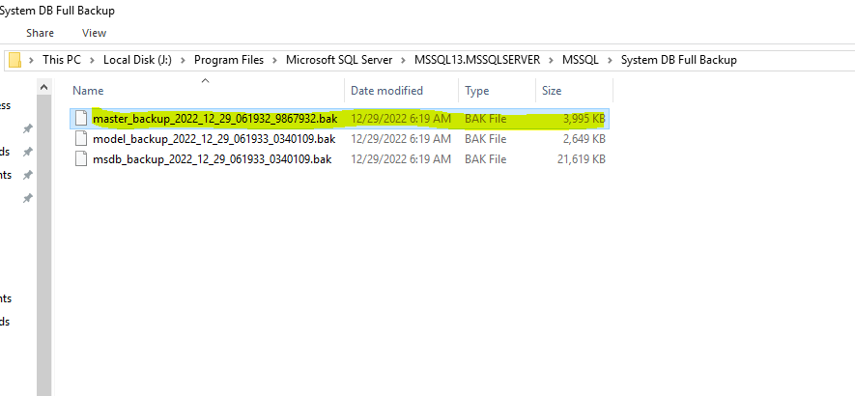--Next put the SQL server into single user mode

Open sql configuration manager🡪stop the other sql components services (Agent, browser, full-text)🡪 next right click on MSSQL server and open properties 🡪 select start up parameter, under that give –m to start sql server in single user mode🡪 click add and apply🡪 post this we need to restart the sql server service

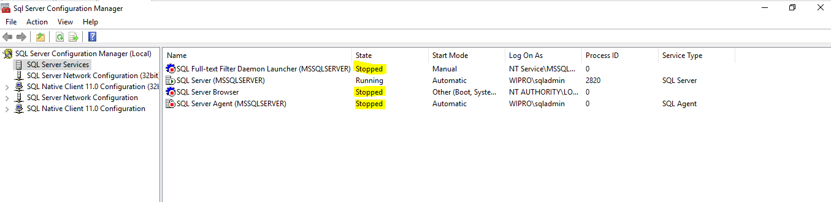

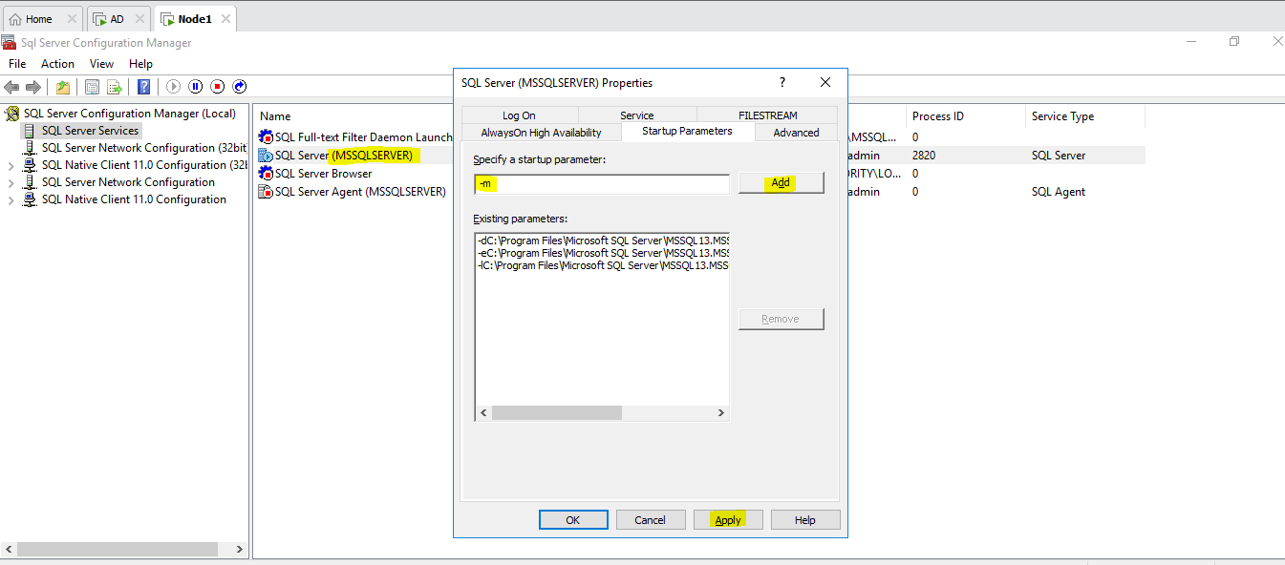

-->now open cmd--> connect to sql via cmd sqlcmd –s Node1\wipro

Here node1 is host name and wipro is instance name

Now connect to the SSMS and restore the Master Db

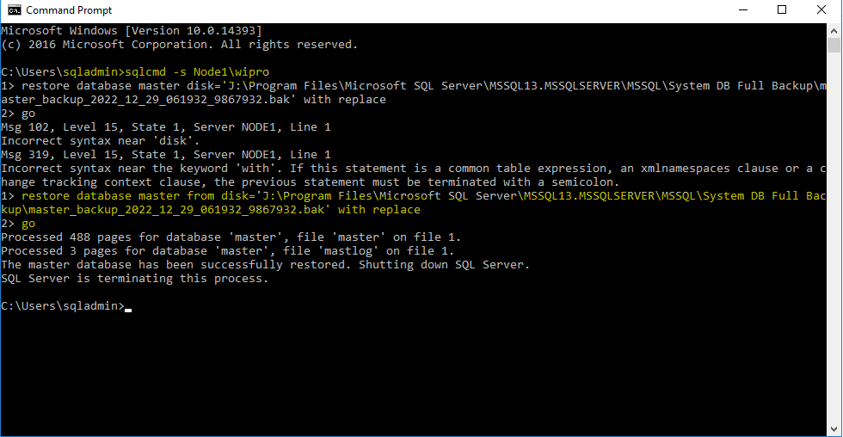

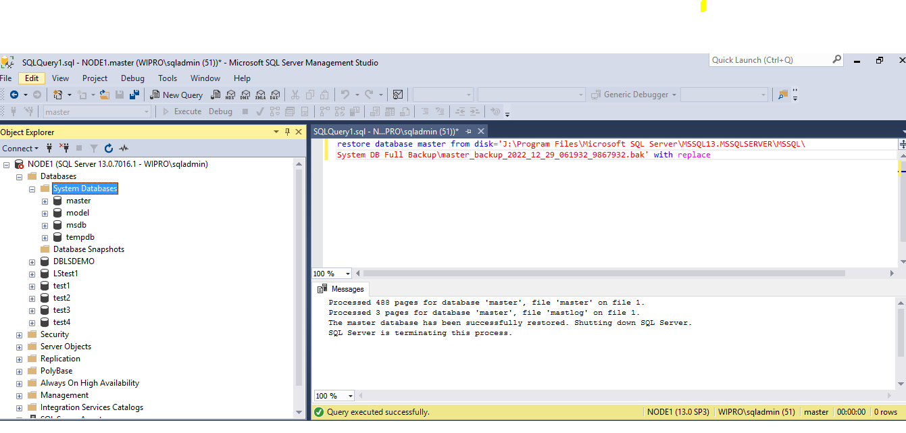

Now go back to the configuration manager and put sql service into multi user mode

Remove –m and click apply ok, now start all the services (Agent, full-text, browser)

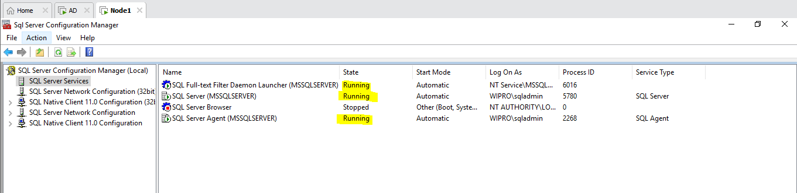

Now we have to conform that we are able to connect or not, select master and open New Query if its gets open then all good

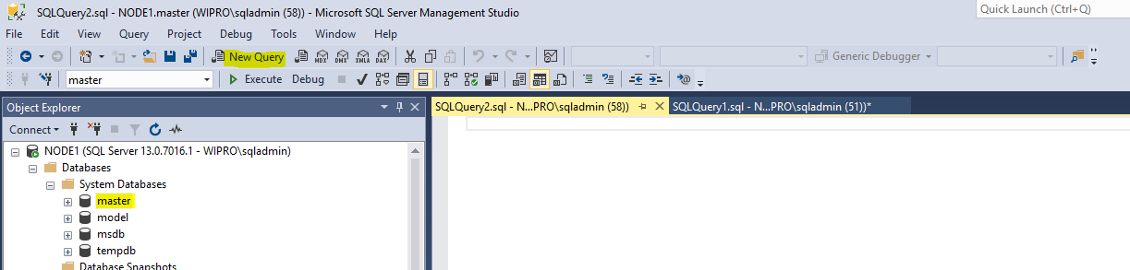

Next we have to try connecting CMD

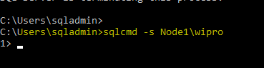

Master got restore and we have put back to multi user mode